Chapter 3, Solution 31

i₀
4 Ω
v₂
v₁
1 Ω
1 A
–
+
10 V
4 Ω
2 Ω
1 Ω
v₃
2v₀
+ v₀ –

At the supernode,

1 + 2v₀ = 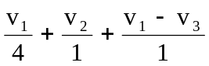 (1)

But v_{o} = v₁ – v₃. Hence (1) becomes,

4 = -3v₁ + 4v₂ +4v₃ (2)

At node 3,
2v_{o} + 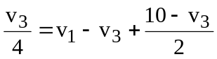

or 20 = 4v₁ + 0v₂ – v₃ (3)

At the supernode, v₂ = v₁ + 4i_{o}. But i_{o} = 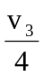. Hence,

v₂ = v₁ + v₃ (4)

Solving (2) to (4) leads to,

v₁ = 4.97V, v₂ = 4.85V, v₃ = –0.12V.

